# Working with Files

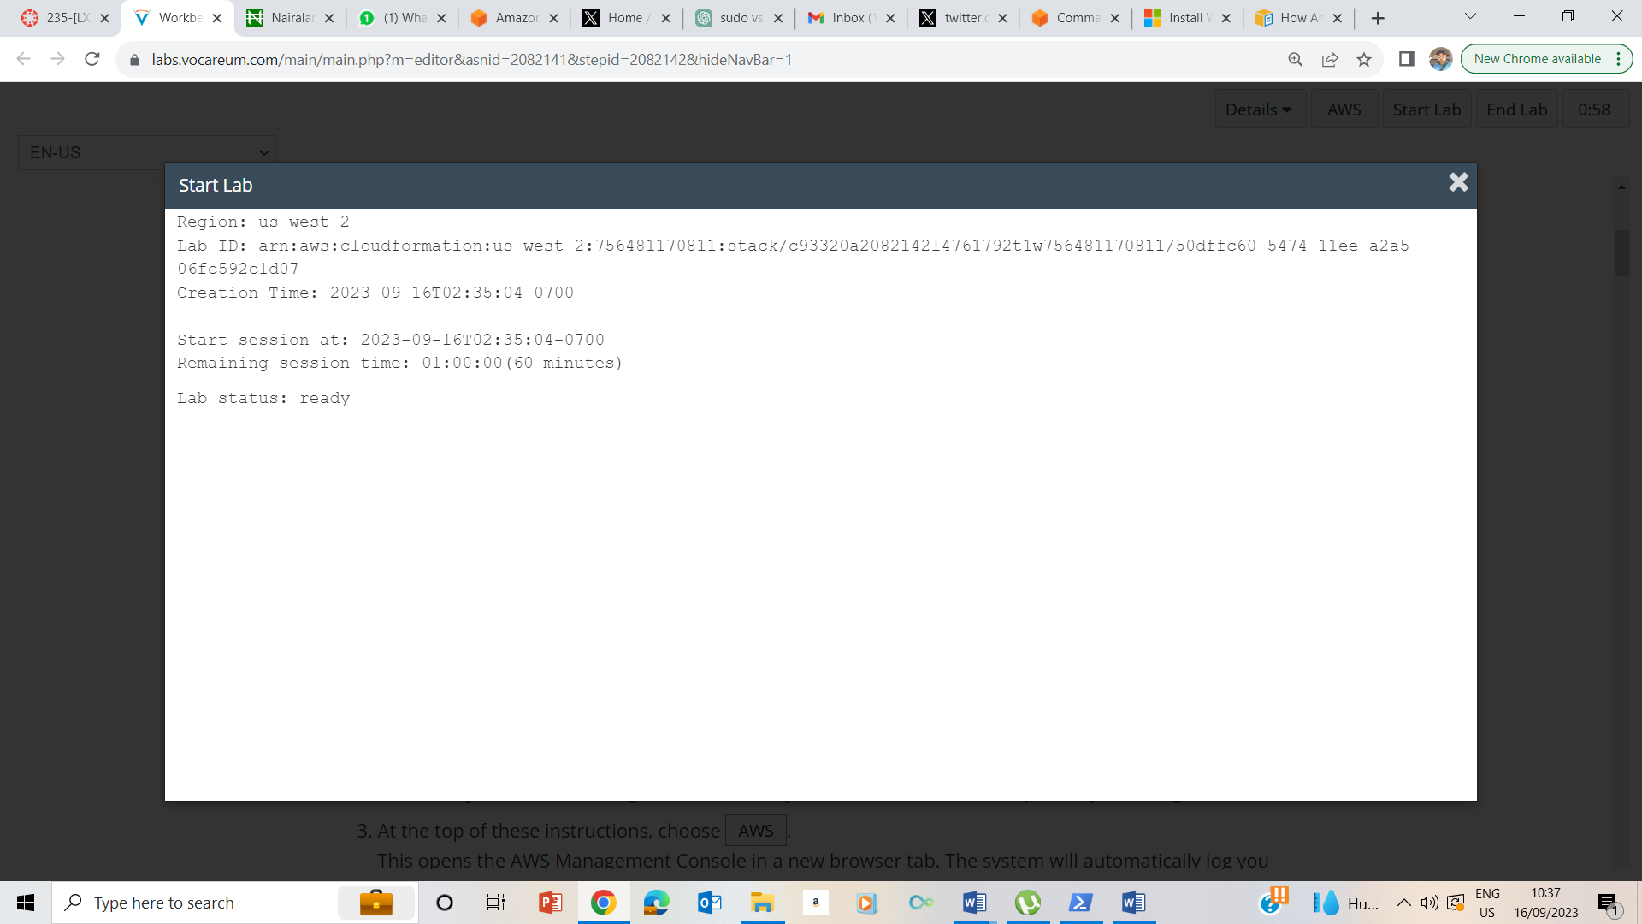

Start Status - Ready

**Accessing the AWS Management Console**

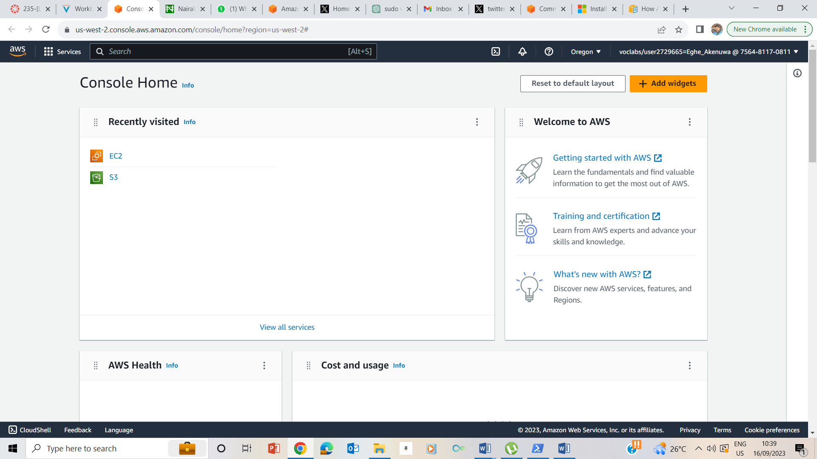

Clicked AWS button and took me to AWS Management console

## Task 1: Use SSH to connect to an Amazon Linux EC2 instance

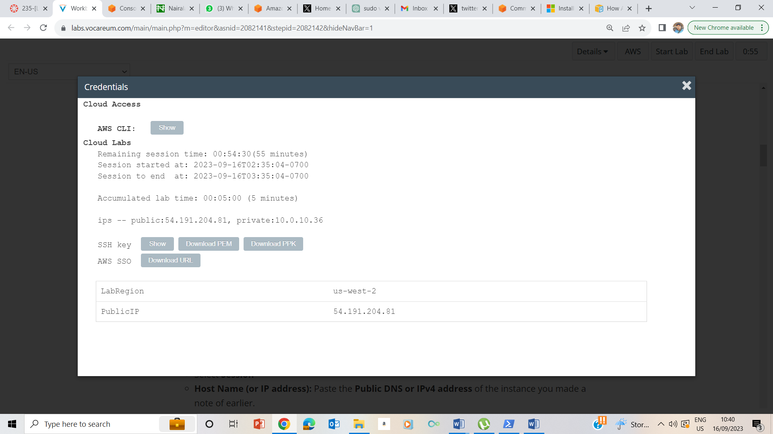

Clicked on the Details dropdown box and clicked on Show. On the credentials page , downloaded PPK and also noted the public ip address

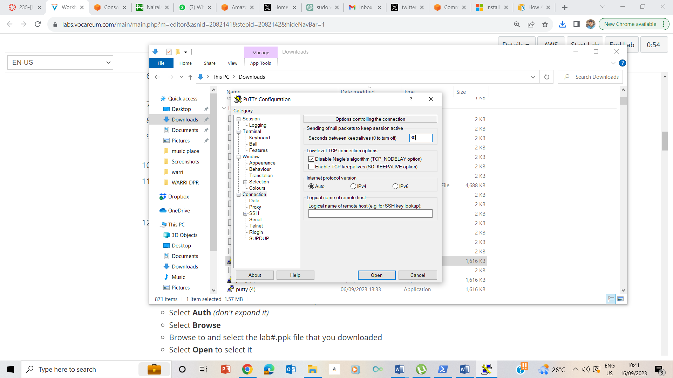

Downloaded Putty, ran the putty.exe file and set the timealives to 30

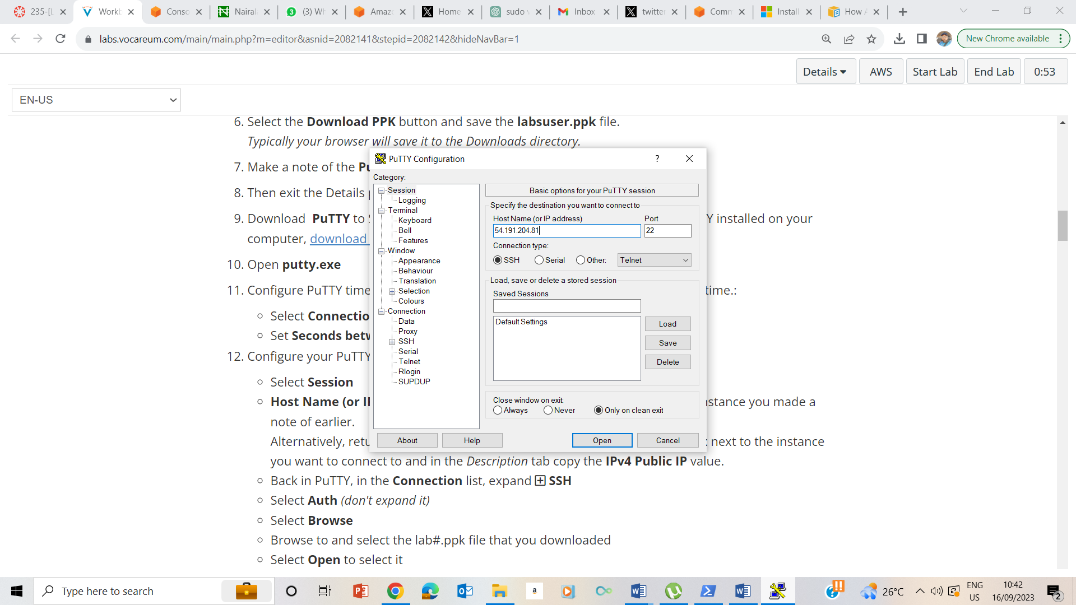

Input the public ip in the session box

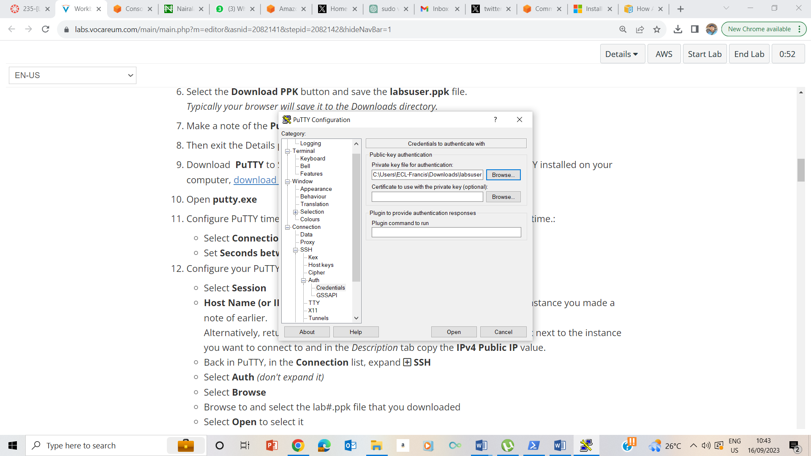

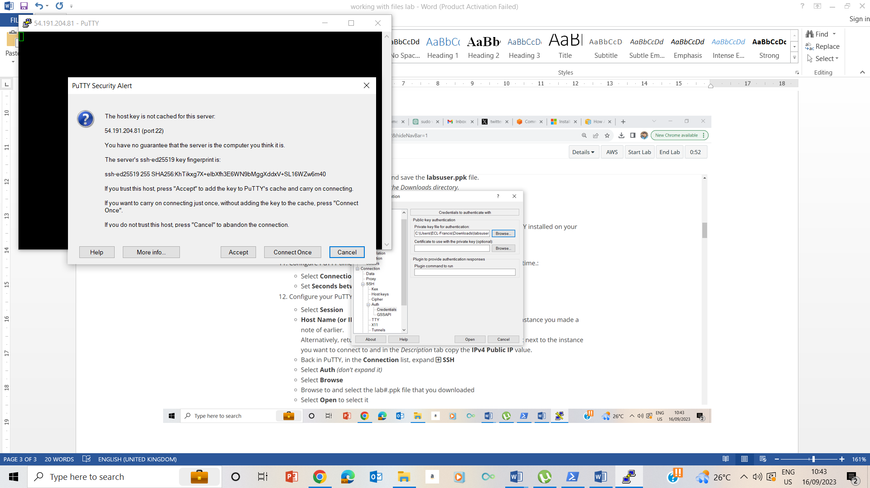

Accept the session to trust and connect to the host.

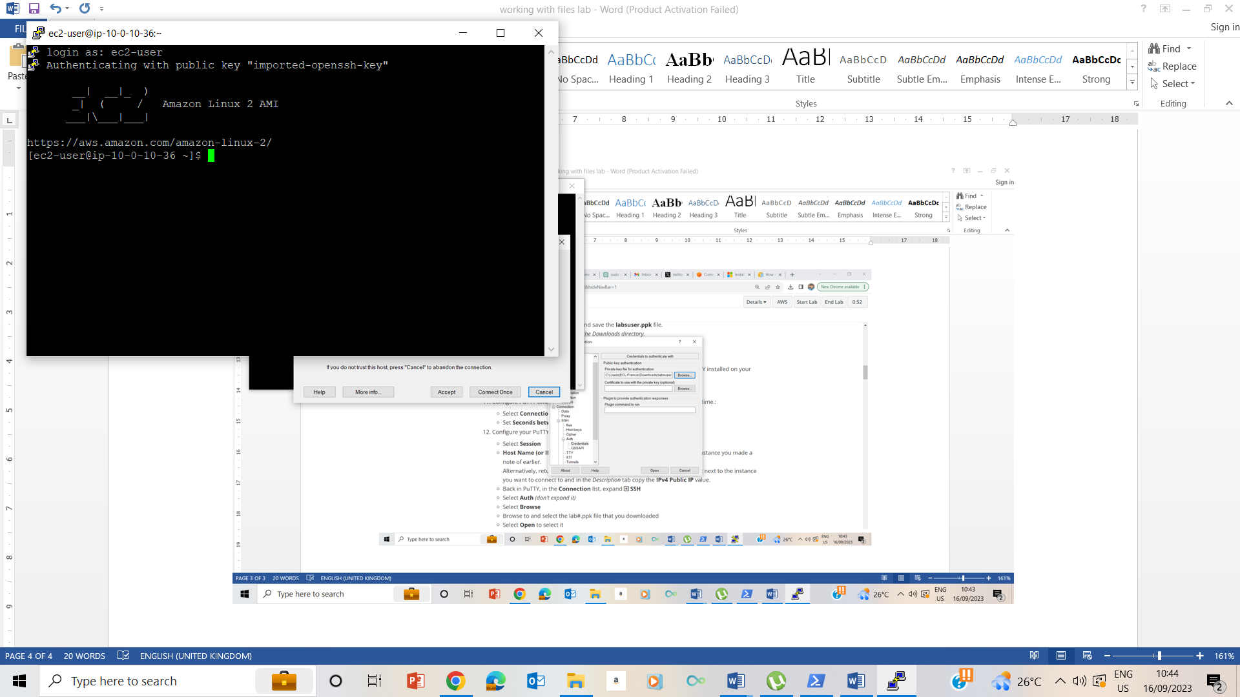

Connected as ec2-user

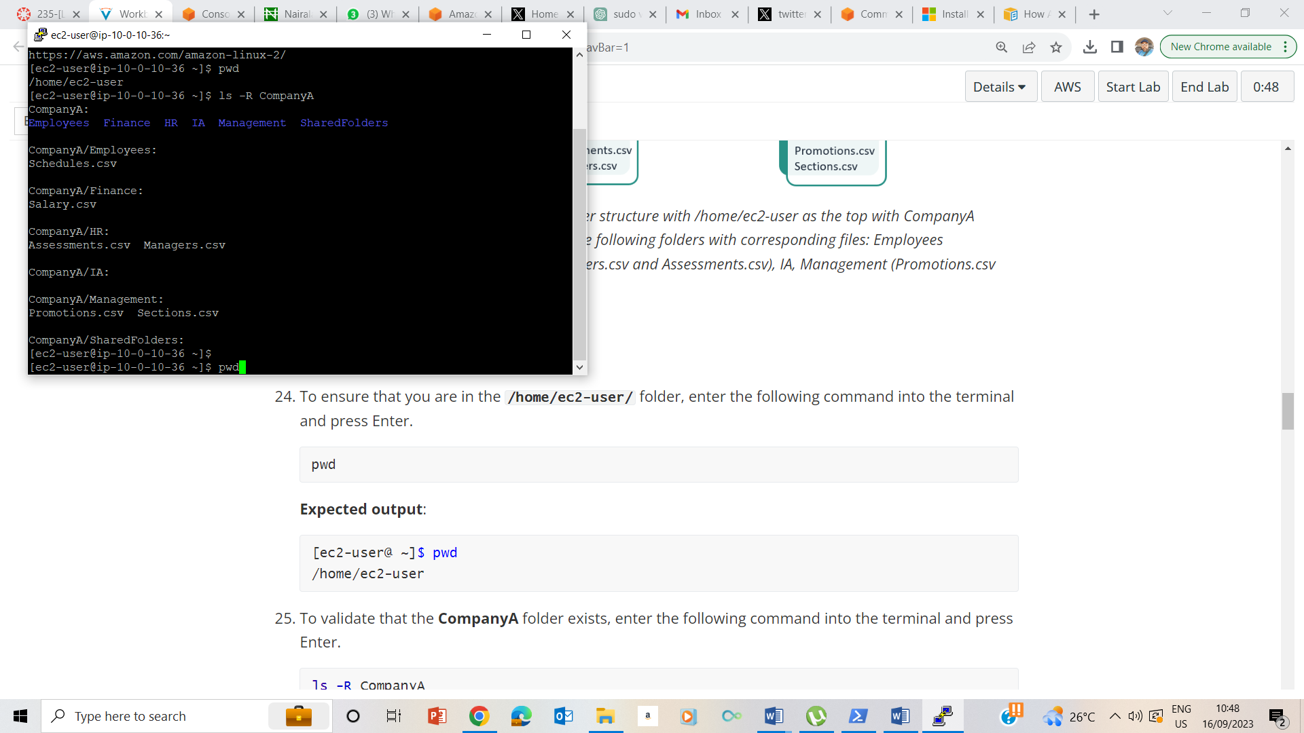

Ls –R CompanyA

26. 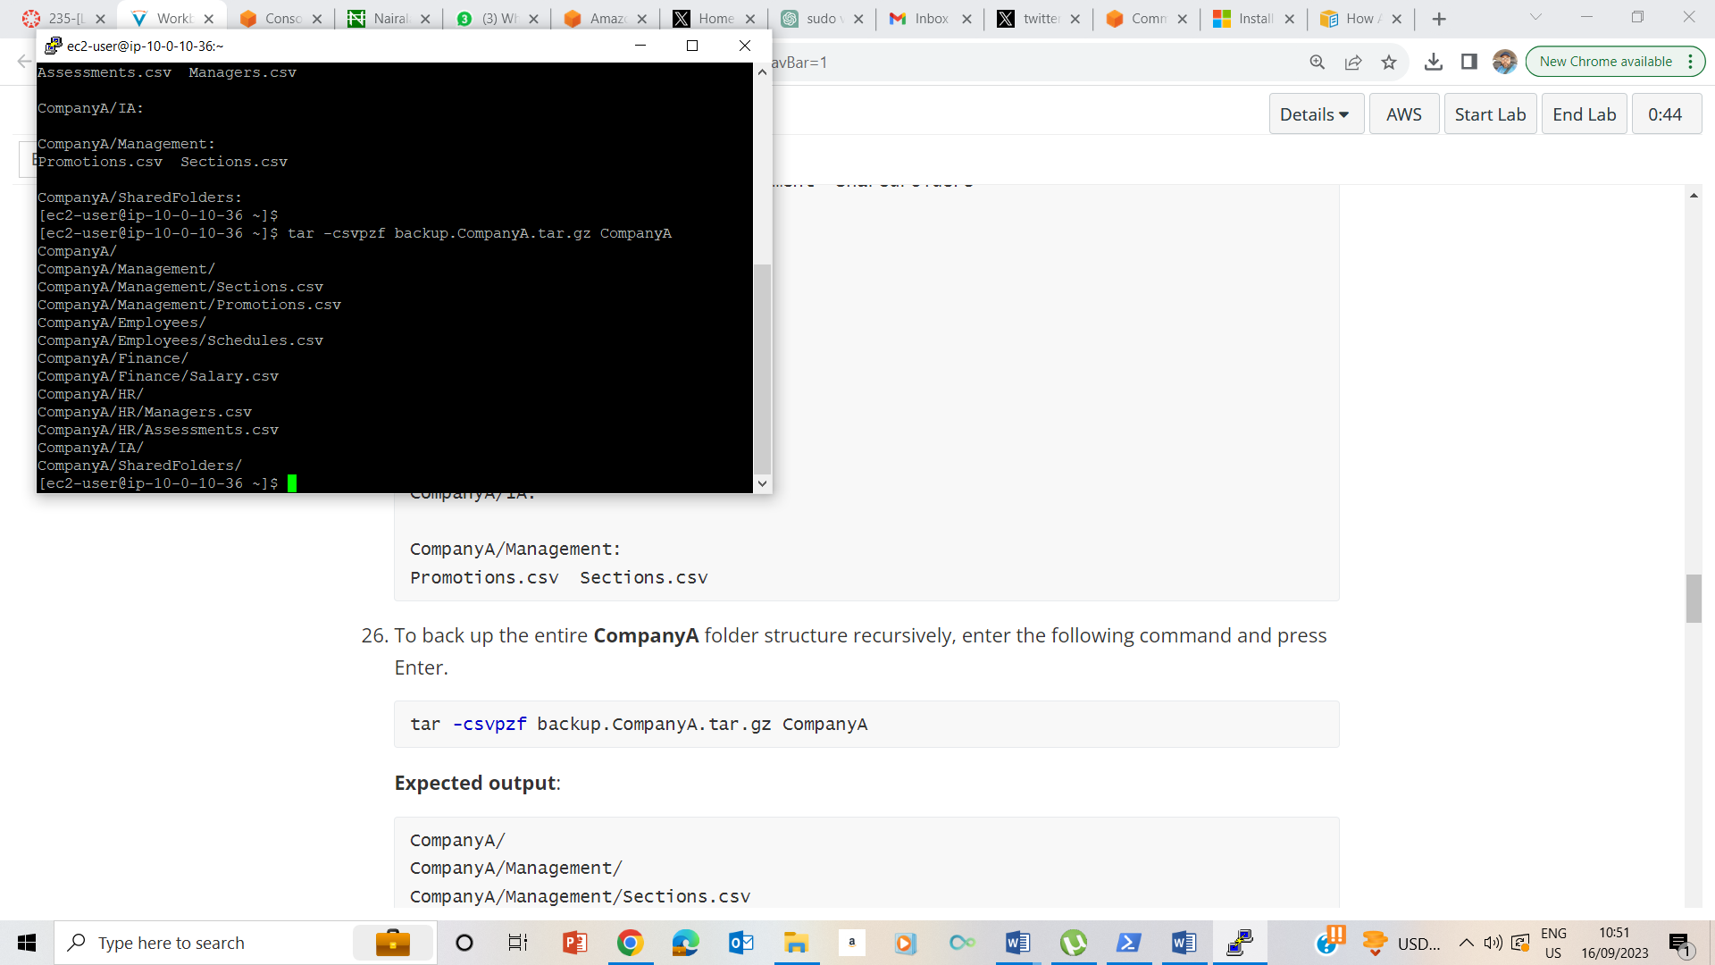Backup of CompanyA file

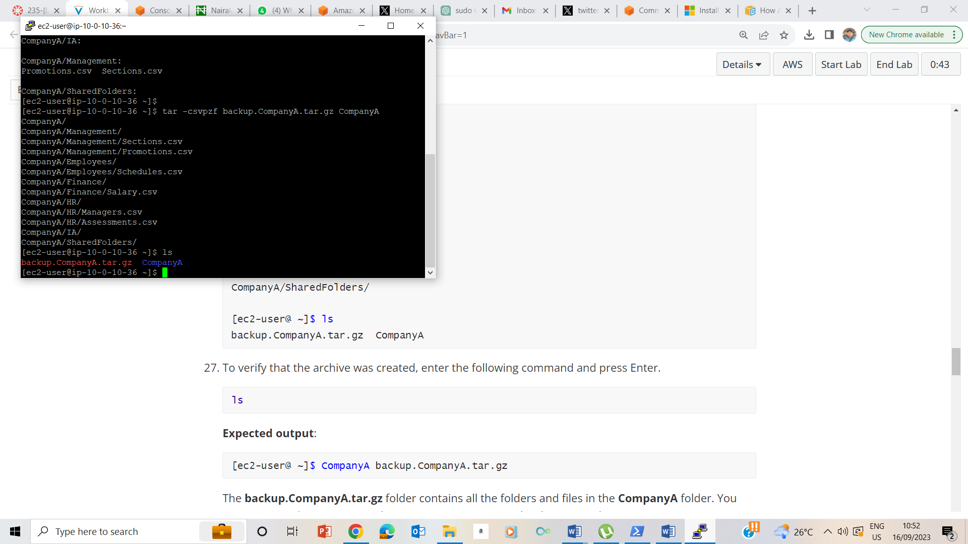

27 Ls showing the backup file of CompanyA

## Task 3: Log the backup

28. 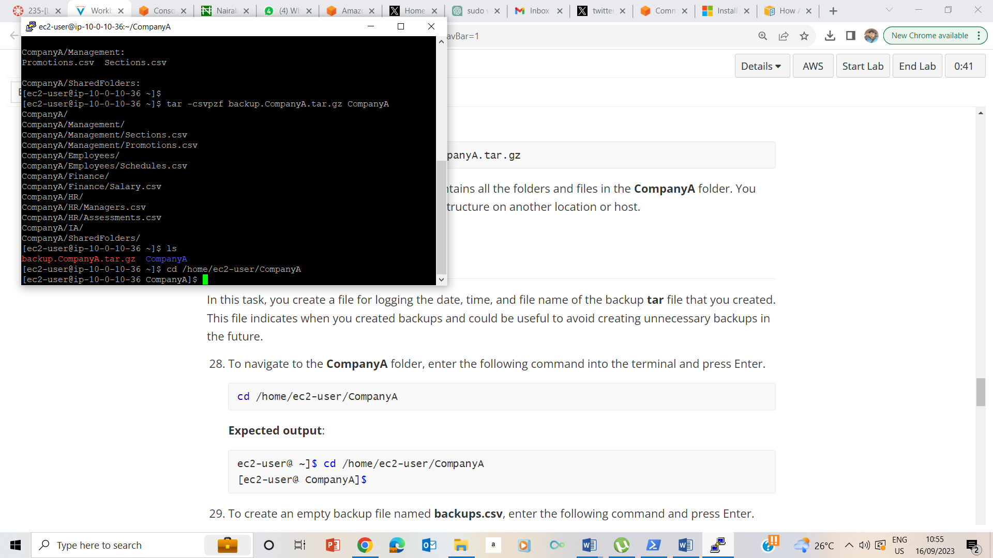

28. LOG the back uo with cd /home/ec2-user/CompanyA

29.

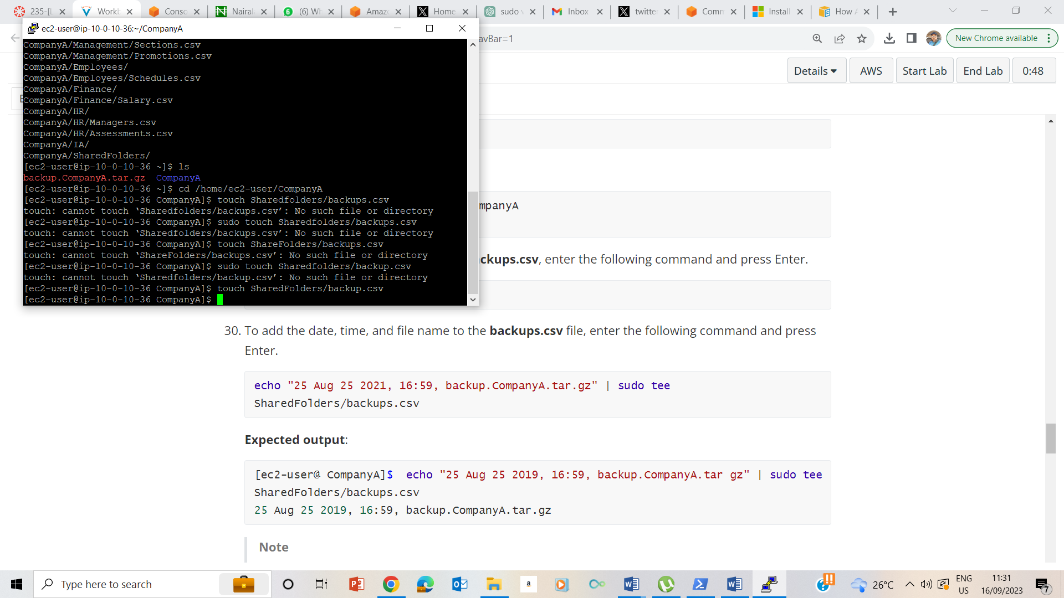

Create a backup file – backups.csv

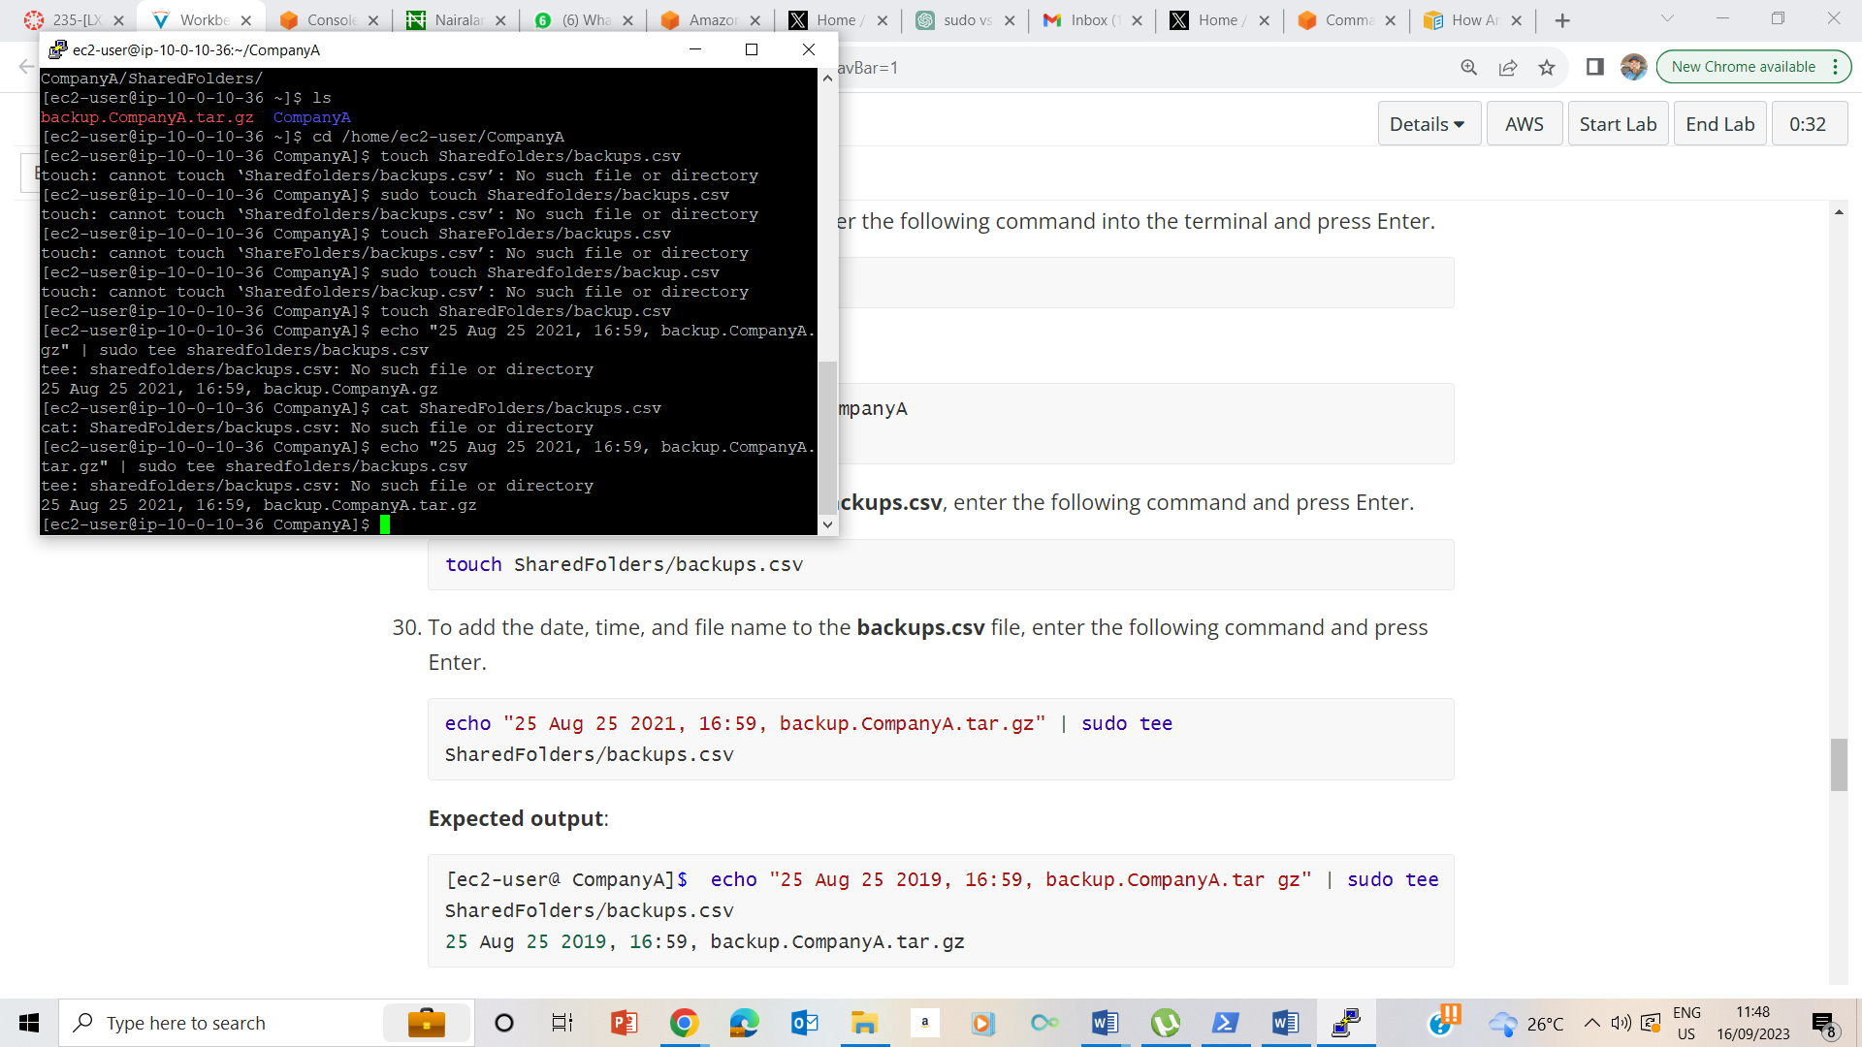

30. Adding date and tome to the newly created file.

## Task 4: Move the backup file

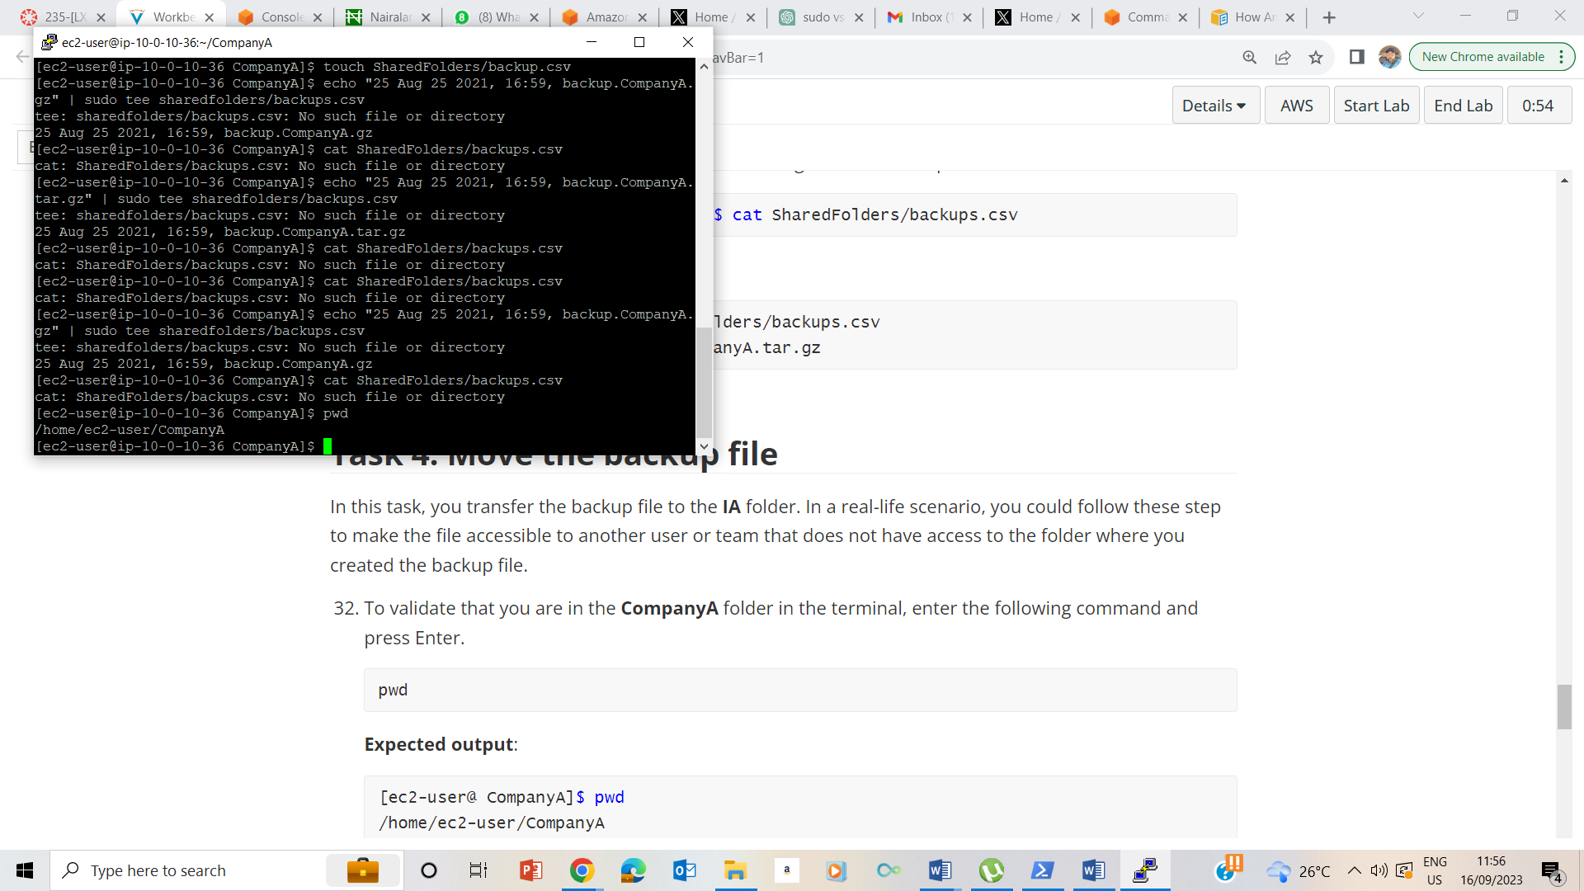

32. Validation that I am in CompanyA folder in the terminal.

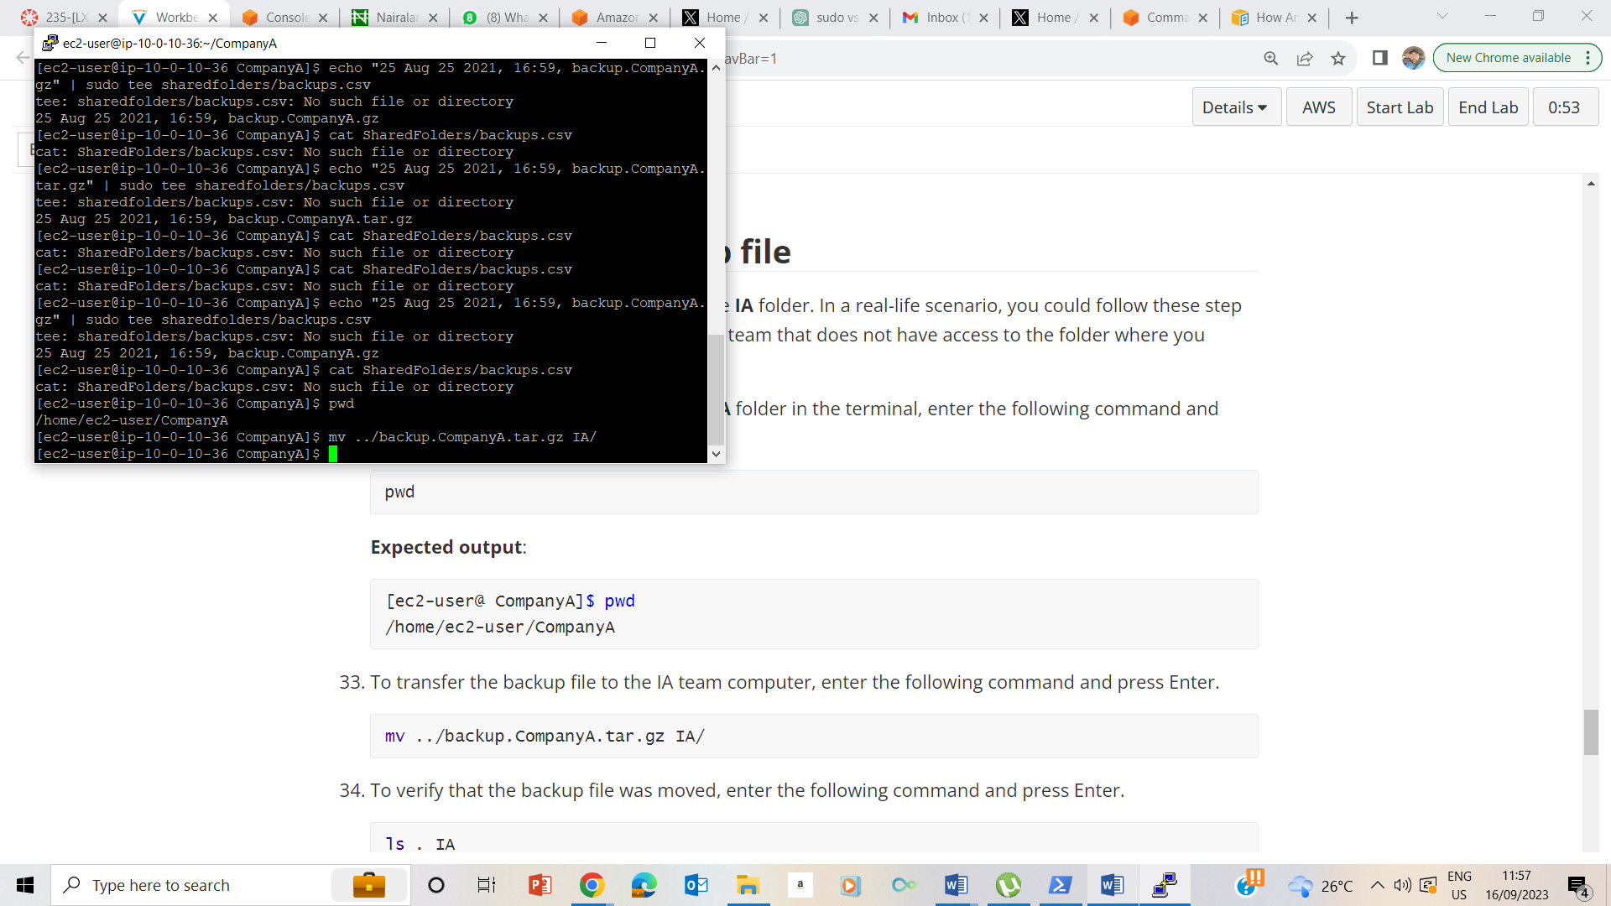

To transfer the backup file to the IA team computer

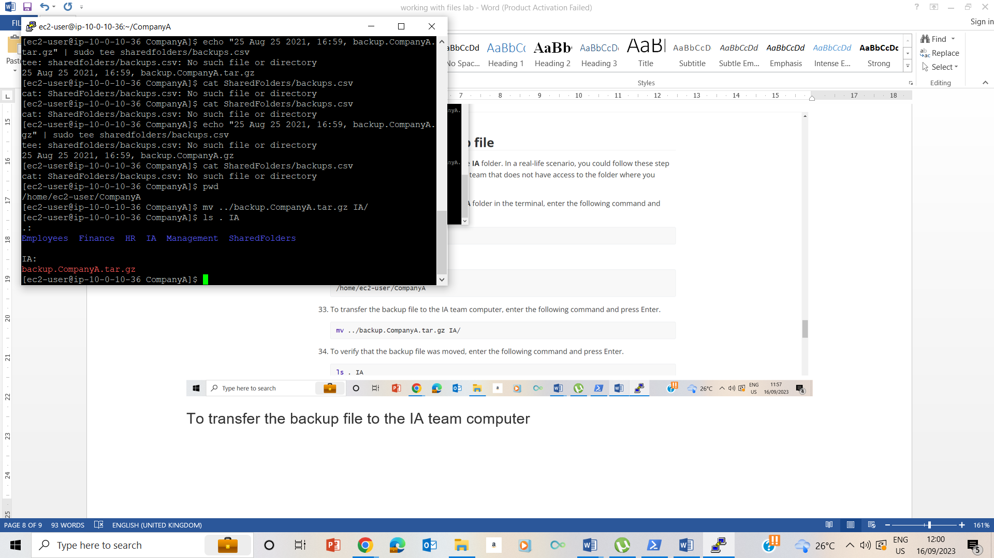

34 To verify that the backup file was moved

## Lab Complete